Parent Copy

t Copy
SUMMER DAY CAMP INFORMATION (Ages 7 to 12)

- Operational hours for the Summer Day Camp Program are 7:45 a.m. to 5:30 p.m.
Children can be dropped off between 7:45 a.m. and 9:00 a.m.
Children are to be picked up between 4:00 p.m. and 5:30 p.m.
Please note that the Summer Day Camp Program ends at 5:30 p.m. sharp. Late pickup charges will be applied at $26.50 for every 15 minutes the parent is late picking up their child.

- Location for Drop off and Pickup:

Weeks 1 – 8: Multiplex Gymnasium

- On rainy days, please send:
- rain jacket/poncho | - rubber boots | - indoor shoes

- For daily activities, children must bring:

- indoor running shoes | - lunch | - 2 snacks
- drinks (no glass bottles) | - sun screen | - bug repellent
- reusable water bottle

5. Day Camp is a NUT FREE Zone due to allergies. Please do not send nut filled snacks or lunches.

6. Water will be available for the children.

7. Swimming is scheduled on Mondays, Wednesdays & Fridays at Ruth Inch Memorial Pool from 1:00 - 3:00 p.m. Children must bring their bathing suit and towel.

8. A lost & found box will be located with the leaders. Please check this box for any lost items.
The City of Yellowknife assumes no responsibility for lost or stolen items.

9. Staff will be checking attendance throughout the day. Please contact the Day Camp Program Coordinator, at 445-4990 or Daycamp@yellowknife.ca if your child(ren) will be absent from the program. A written note to the staff is requested for all early departures. If you are dropping off your child late please inform the staff of their arrival.

10. The informed consent form and playground information registration forms must be completed and returned to the Community Services Department before your child’s participation in the Day Camp program.

11. Cancellation requests must be made 48 hours prior to the start of the program to receive a %100 refund.
• If the program has commenced, the refund reflects a percentage of the program remaining from time of notification. All requests made after the program commencement are subject to a $20 service charge.
• No refunds will be issued after the mid-point of a program.

12. Please keep your receipt. There is an additional charge of $30 for any additional copies of receipts.


Summer Day Camp Coordinator Copy

SUMMER DAY CAMP REGISTRATION INFORMATION

Child’s Name: Male: Female:

Age: Date of Birth:
Year Month Day

In Case of Emergency

Contact Name: Phone:

Cell Phone:

Alternate Contact: Phone:

Cell Phone

MEDICAL INFORMATION

Please list all conditions, needs, behavior, illnesses, disabilities (learning or physical) and medical conditions for you child which may limit your child’s participation in the Day Camp Program.

Yes Please specify_________________________________________________________
No

Has your child had any illness, injury or operations of which the staff should be aware of?

Yes Please specify_________________________________________________________
No

Does your child receive any support or special assistance at school?

Yes Please specify_________________________________________________________
No

Does your child take any medication?

Yes Please specify_________________________________________________________
No

Page 1 of 2
Does your child suffer from any allergies (or any other pertinent health information)?

____________________________________________________________________________
Are there any special instructions for your child?
___________________________________________________________________________

(Parents/guardians are responsible for any ambulance fees that may be incurred.)

OTHER INFORMATION

Will you be picking up your child each day? YES NO

Is your child to walk home or to your office at the end of the day? YES NO

Please specify time:

Please note that the Summer Day Camp Program ends at 5:30 p.m. sharp. Late pickup charges will be applied at $26.50 for every 15 minutes the parent is late picking up their child.

Inclusion information for Day Campers
For all children to have the best day camp experience, please make us aware of any needs that your child may have the will affect their participation. There are times when a child requires more support than our ratios provide. In this case a day camp supervisor may request the parent/guardian to provide a support worker/aide to attend camp with their child. In addition the City of Yellowknife will have additional staff available to ensure all campers have a positive experience by providing support as required.

PLEASE RETURN TO CITY HALL OR TO SUMMER DAY CAMP STAFF ASAP OR EMAIL DAYCAMP@YELLOWKNIFE.CA

DM#51991-v1

City Hall Copy

The City of Yellowknife Day Camp Program
Informed Consent

I _______________________________ (name of Parent/ Guardian) am authorized and request to have

__________________________________________ (“my Child”) participate in the City of Yellowknife’s

____________________________________________________ Day Camp Program (the “Program”).

I AM AWARE AND ACKNOWLEDGE that the Program involves many inherent RISKS, which Risks include but are not limited to the possibility of personal injury such as skin abrasions, nerve, bone, spinal cord and neck damage, pain, paralysis, brain injuries or even death, property damage and property loss.

I UNDERSTAND that the above activities require a minimum level of fitness and physical mental and emotional health (collectively “health”). I further understand that the probability of the Risks occurring depends in part on my Child’s level of fitness and health as well as on that awareness, care and skill with which my Child conducts him or herself in the program.

I WARRANT that my Child is physically, mentally and emotionally fit to participate in the Program.

I UNDERSTAND, AGREE AND ACKNOWLEDGE that:
a. By choosing to have my Child participate in the Program brings with it the assumption by me that and by my Child of the risk and I ASSUME FULL RESPONSIBILITY to instruct my Child about the Risks and the choices available to him or relative to those Risks.
b. I am free to withdraw my Child from the Program at any time up to the mid point of the Program. I agree to withdraw my Child from the Program immediately if my Child begins to experience any signs of transient lightheadedness, fainting, chest discomfort, leg cramps, nausea or other similar ailments.
c. The City of Yellowknife is not responsible for administering medication to my Child or for providing any medical treatment on an emergency basis or any other. If my Child takes medication it is my responsibility to see that he or she does so.
d. The City of Yellowknife reserves the right to photograph program participants and publish them in our publications and on our website.

I declare that I have read, understood and agree to the contents of the INFORMED CONSENT form in its
entirety this_____________________day of ________________________, 201______.

_______________________________________ ___________________________________
Parent/ Guardian Witness

Community Services Department
City of Yellowknife
Box 580
Yellowknife, NT
X1A 2N4
Fax: (867) 920-5668
Daycamp@yellowknife.ca

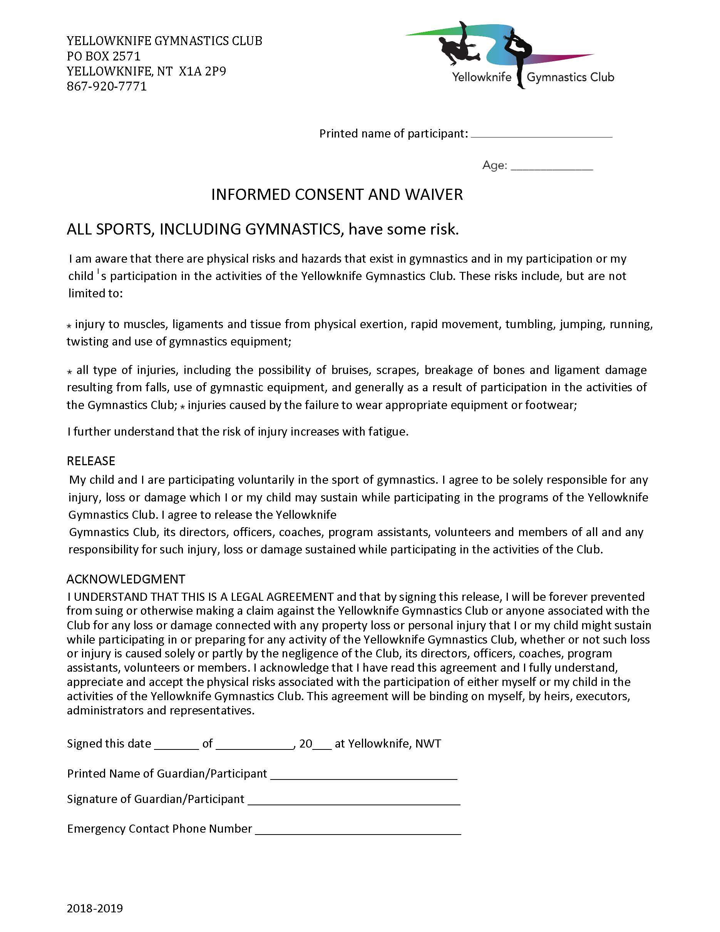


CLIMBING WALL INFORMED CONSENT AND ACKNOWLEDGMENT OF RISKS AGREEMENT
(FOR MINORS)

Minor’s Full Name: __________________________________
Minor’s Date of Birth: __________________________________
Parent or Guardian’s Full Name: __________________________________
Address of Minor: __________________________________
Phone Number of Parent or Guardian: __________________________________

TAKE NOTICE!
BY SIGNING THIS DOCUMENT, YOU WILL BE GIVING UP CERTAIN LEGAL RIGHTS, INCLUDING THE RIGHT TO SUE

- PLEASE READ CAREFULLY -

ASSUMPTION OF RISK

I am aware that my child’s participation in the activities of climbing, rappelling, belaying, spotting, rescue systems, bouldering, and any other related activity (the “Activities”) in the climbing facility located at the City of Yellowknife’s Fieldhouse (the “Facility”) has many inherent risks, dangers and hazards, including but not limited to the following:

- injury resulting from slips or falls on footholds, handholds, uneven ﬂoors, decks, ﬂoor padding, or mats;
- injury resulting from collision with climbing wall features such as protruding rocks, ledges, edges, railings, outcroppings, or access ladders;
- injury resulting from the use, misuse, non-use or failure of any of the equipment used in the Facility, including but not limited to ropes, slings, harnesses, climbing hardware, automatic belay devices, anchor points, and any other part of the climbing structure (the “Equipment”);
- rope abrasion, entanglement and other injury which results from the use of ropes;
- injury resulting from collisions with other users of the Facility;
- injury resulting from the actions of other users of the Facility;
- injury resulting from falling climbers, dropped items, or falling Equipment;
- cuts and abrasions resulting from skin contact with the climbing wall; and
- theft, vandalism or loss of personal property. (collectively, the “Risks”)

I understand and will instruct my child that the City’s Climbing Wall Guidelines and the age restrictions on the Activities must be followed and at all times the sole responsibility for personal safety remains with my child. I acknowledge that the Guidelines may change and it is my responsibility to inform myself and my child of the City’s Climbing Wall Guidelines which are posted at the Facility and available at www.yellowknife.ca.

I will direct my child to obey all instructions that my child receives from Facility employees, climbing wall instructors, or volunteers. I acknowledge on my child’s behalf that the City will not be responsible for any injury that occurs as a result of my child’s failing to obey Facility employees.

I have satisﬁed myself and believe that my child is physically, emotionally and mentally able to participate in the Activities. I will notify Facility employees if my child has any condition or requires any medication that may aﬀect my child’s ability to participate in the Activities or which may aﬀect my child’s interactions with employees or other users of the Facility.

I authorize City employees and volunteers to consent to emergency medical treatment in accordance with the best interests of my child should I not be present at the relevant time to grant consent myself.

INFORMED CONSENT

In consideration of the City allowing my child to participate in the Activities, I agree that:

  - I consent to my child’s participation in the Activities and I freely and voluntarily accept and assume on behalf of my child all of the Risks associated with the Activities and recognize that these Risks may result in property damage, all manner of personal injury (including serious injuries such as fractures, spinal cord injury and brain injury) and death;
________ (initial)

  - I acknowledge on my child’s behalf that the City is not responsible for (1) the use of any Equipment by my child without proper training, (2) the improper use of any Equipment by my child, and (3) the use or functionality of any Equipment that is not owned by the City;
________ (initial)

  - I recognize on my child’s behalf that the City is not responsible for the actions of other users of the Facility. I have instructed my child to be aware of and pay attention to other users of the Facility while participating in the Activities; and
________ (initial)

  - I accept all responsibility for the actions of my child while they are at the Facility. If damage to property or injury to persons is caused by the actions of my child, I will be personally responsible for all such damages or injuries.

This agreement will be eﬀective and binding upon my child’s heirs, next of kin, executors, administrators, assigns, attorneys, and representatives in the event of my child’s death or incapacity.
________ (initial)
________ (initial)

I certify that my child is over the age of four, that I am the legal parent or guardian of the child and that I have full legal responsibility for decisions regarding my child. I have carefully read this Informed Consent and Acknowledgement of Risk Agreement.

Signature of Parent/Guardian Signature of Witness

Witness Name (Printed)

Date Date

