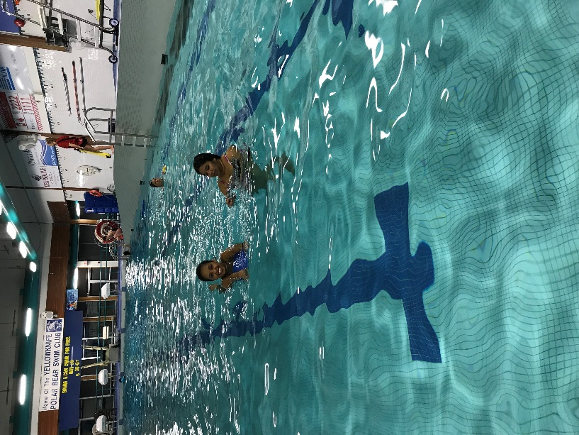

**Ladies Only Swim Night**

For ladies and girls 9+ years old   
Learn to swim with a teacher  
Wear clean clothes

Only female lifeguards

**Date: Saturday, June 15**

**Time: 8:30 – 9:30 pm**

**Place: Ruth Inch Memorial Pool**

**6002 Franklin Ave.**