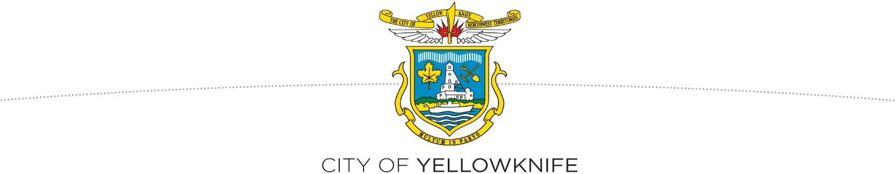
NOTICE OF DEVELOPMENT APPROVALS
March 11, 2022

The following development permit applications have been approved by the Development Officer. Any persons claiming to be adversely affected by the development may, in accordance with the Community Planning and Development Act, appeal to the Development Appeal Board, c/o City Clerk’s Office, tel. 920-5646, City of Yellowknife, P.O. Box 580, Yellowknife, NT X1A 2N4. Please note that your notice of appeal must be in writing, comply with the Community Planning and Development Act, include your contact information and include the payment of the $25 appeal fee. (The appeal fee will be reimbursed if the decision of the Development Officer is reversed.)

Date of Decision: March 7, 2022
#PL-2022-0030 Lot 31, Block 568, Plan 4452 (229 Grace Lake Boulevard)
Intended Development: Single Detached Dwelling
The minimum side yard setback has been decreased from 3.00m to 2.85m (5% variance) on the eastern side of the dwelling, and has been decreased from 3.0m to 2.86m (4.67% variance) on the western side of the dwelling.
#PL-2022-0016 Lot 19, Block 146, Plan 863 (5137 Forrest Drive)
Intended Development: Detached Secondary Suite
Last Date to Appeal: March 21, 2022

Date of Decision: March 8, 2022
#PL-2022-0037 Lot 36, Block 501, Plan 4590 (156 Hall Court)
Intended Development: Residential Addition
The Maximum Height has been increased from 7.5m to 7.85m (4.46% variance)
The Side Yard Setback has been reduced from 2.4m to 1.804m (24.83% variance)
Last Date to Appeal: March 22, 2022

Additional information may be obtained by contacting the City of Yellowknife at (867) 920-5600.

Dated the 11th of March, 2022.

DM #682098

