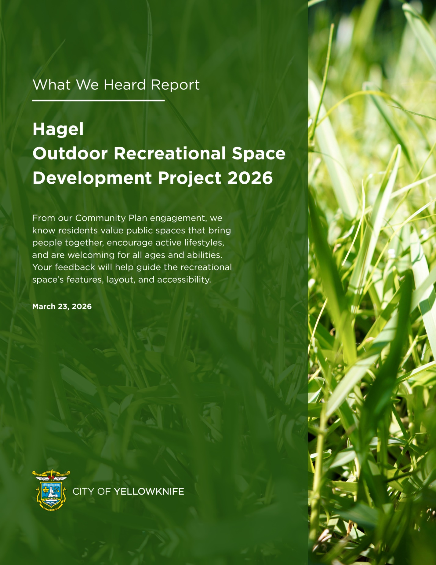

Table of Contents
1. Introduction 3
2. Engagement Approach 3
3. Demographic Profile of Participants 3
4. Key Findings 5
A) Accessibility and Access 5
B) Site Character & Environment 6
C) Desired Features 6
D) Safety & Supervision 7
E) Cultural & Community Reflection 8
6. What Happens Next 8

1. Introduction
Yellowknife’s parks and public spaces support recreation, connection, and community well-being year-round. The City’s Community Plan Update confirmed the importance of safe, inclusive, accessible, and connected spaces to the natural environment.
As part of the Yellowknife Play Spaces 2026 initiative, the City is planning a new outdoor recreational space between Hagel Drive and LeMay Drive. This space is intended to serve the growing residential area and provide opportunities for recreation and community use.
To inform this work, the City invited residents to share input through a public survey. The survey focused on how the space may be used, which features are most important, and what should be considered in its design.
This engagement was conducted at the “Consult” level of the International Association for Public Participation Spectrum of Public Participation. Feedback will inform design options alongside technical requirements, site conditions, and budget.

2. Engagement Approach
The City conducted a public survey from March 2 to March 13, 2026 to gather input on the future Hagel Drive outdoor recreational space.
This engagement was carried out at the “Consult” level of the International Association for Public Participation Spectrum of Public Participation. At this level, feedback informs planning and design decisions.
An online survey was selected as the primary engagement method to provide a quick and accessible way for residents to share input within a limited timeframe. This approach allowed the City to gather feedback before issuing a Request for Proposals (RFP) for the design of the space.
The survey was promoted through City communication channels, and 99 responses were received.

3. Demographic Profile of Participants
The survey reached a highly local audience, with 85.9% of respondents living within walking distance of the Hagel recreational site.
- Potential Users: The majority of respondents plan to visit the space with children in their household (64.6%).
- Primary Age Groups: The space is expected to serve a young demographic, with 64.6% of households including children under 5 and 60.6% including children aged 5–12.

(Section 3) Figure 1: Age Groups Likely to Use the Hagel Space

- Frequency of Use: Demand for the space is high, with 42.4% of participants indicating they plan to visit the space daily and 39.4% weekly.

(Section 3) Figure 2: Projected Use of the Space

4. Key Findings
Respondents shared input on accessibility, site character, desired features, safety, and community elements for the proposed Hagel Drive outdoor recreational space.

A) Accessibility and Access
The space is expected to be primarily accessed by walking or biking, with most respondents indicating active transportation.
Accessibility was a key theme. Respondents identified the need for:
- Wheelchair-accessible features and ramps
- Wide, paved pathways
- Stroller-friendly design
- Smooth and accessible surfacing
Several responses also noted a preference for rubberized surfaces over sand or gravel to support mobility.

Feature Category | Mentions | Supporting Resident Quotes
Wheelchair & Ramp Access | 35 | "Ramps. Works for seniors as well. Wide entry points to equipment." ; "Basic accessibility of ramps/wheelchair access."
Paved Paths & Wide Sidewalks | 33 | "Wide sidewalks generally make for a better experience as they can then function as shared-use paths." "Flat paved paths... clear pathways."
Sensory Elements | 11 | "Sensory elements and paths... sensory equipment."
Stroller-Friendly Design | 7 | "Easy access for strollers with appropriate grades and not having to go over curbs or bumps." ; "Ramps for strollers."
Rubber Flooring | 5 | "Wheelchair access, all grass/gravel replaced with rubber floor." ; "No sand, ideally rubber floor... accessible."
(Section 4A) Table 1: Top 5 Categories for Accessibility Features

B) Site Character & Environment
Many respondents expressed interest in a natural and green environment.
- Nature Focus: 74% of participants selected a Nature/Forest/Land-based theme.
- Greenery: The community has established a preference for enhanced greenery and natural canopy cover (73.7%). Respondents emphasized that the space should serve as an ecological offset to the surrounding high-density development.

Natural shade or trees; Landscaping and greenery; the area right now is very grey after all the construction and blasting and dusty with the gravel roads, some greenery and trees would be nice.

C) Desired Features
Participants prioritized versatile outdoor elements. While 82% of respondents believe multi-age integration design is needed within the space to support multi-age use, ensuring that youth and adults have functional areas alongside children's play structures.
Rank | Category | Mentions | Supporting Resident Quotes
1 | Green Space / Minimal Design | ~18 | "Keep the Hagel space minimal to match its small size... Design as a quiet pocket park: Green lawn with picnic tables, no equipment beyond that."  "We need more green space/trees. Not a kid’s swing that get used once a year, like the other small parks in Niven."  "Would be nice to have a green space to break up internal traffic noise for those that live there."
2 | Playground / Kids Space | ~15 | "Please follow through on the promise and make a playground that is large enough for the many kids in the neighborhood."  "Play space for kids!"
3 | Multi-use / Flexible Space | ~12 | "Try to make it usable for most groups, parents can use one or two gym equipment things while kids are playing."  "A multi-use like a combined basketball and tennis court would work well."
4 | Seating & Amenities | ~10 | "Make sure there is good seating and garbage cans."  "A rain/sun shelter and seating would be nice."
5 | Safety (Dogs / Traffic) | ~10 | "Keep it safe by keeping dogs and wildlife out."  "Enclosed as it is a high traffic area."  "Lighting, so the area doesn’t become a target [for vandalism or safety issues]."
(Section 4C) Table 1: Top 5 Categories for Desired Features

D) Safety & Supervision
Safety was frequently raised, particularly given the site’s proximity to roads and residential density. Many respondents listed multiple concerns:
- Visibility: 44 individual mentions identified lighting as a non-negotiable requirement for winter safety and the prevention of vandalism.
Good lighting so it can be used in winter… Lighting that does not create light pollution for sky viewing & aurora viewing.

- Traffic & Pedestrian Safety: Respondents prioritized fencing as a primary safety feature to buffer the play area from road traffic and animals. Although some residents desire to maintain the site's visual openness, the data suggest that a secure, enclosed environment is essential for the comfort and safety of the primary user demographic (households with children under 5).

Include high-visibility items like crosswalk light buttons and speed zone decreases.

- Play Surfacing: Of the 15 mentions for surfacing, 100% of those who specified a material preference requested a move away from sand toward "rubber," "soft," or "grass" surfaces.
Surface should be safe...no gravel or woodchips that get stuck in shoes.

E) Cultural & Community Reflection
Feedback regarding cultural elements was mixed. Some respondents expressed interest in:
- Local art or northern themes
- Indigenous representation
- Opportunities for storytelling or interpretation
Others preferred a simple design without additional cultural or artistic features.

6. What Happens Next
The feedback collected through this survey will inform the development of design options for the Hagel Drive outdoor recreational space.
The City will be issuing a Request for Proposals (RFP) to engage a consultant to lead the design of the space. The results of this engagement will be shared with the selected consultant to help guide the design process.
As part of the “Consult” level of the International Association for Public Participation Spectrum of Public Participation, community input will be considered alongside technical requirements, site conditions, and budget.
Updates on the project will be shared on the City’s website.

