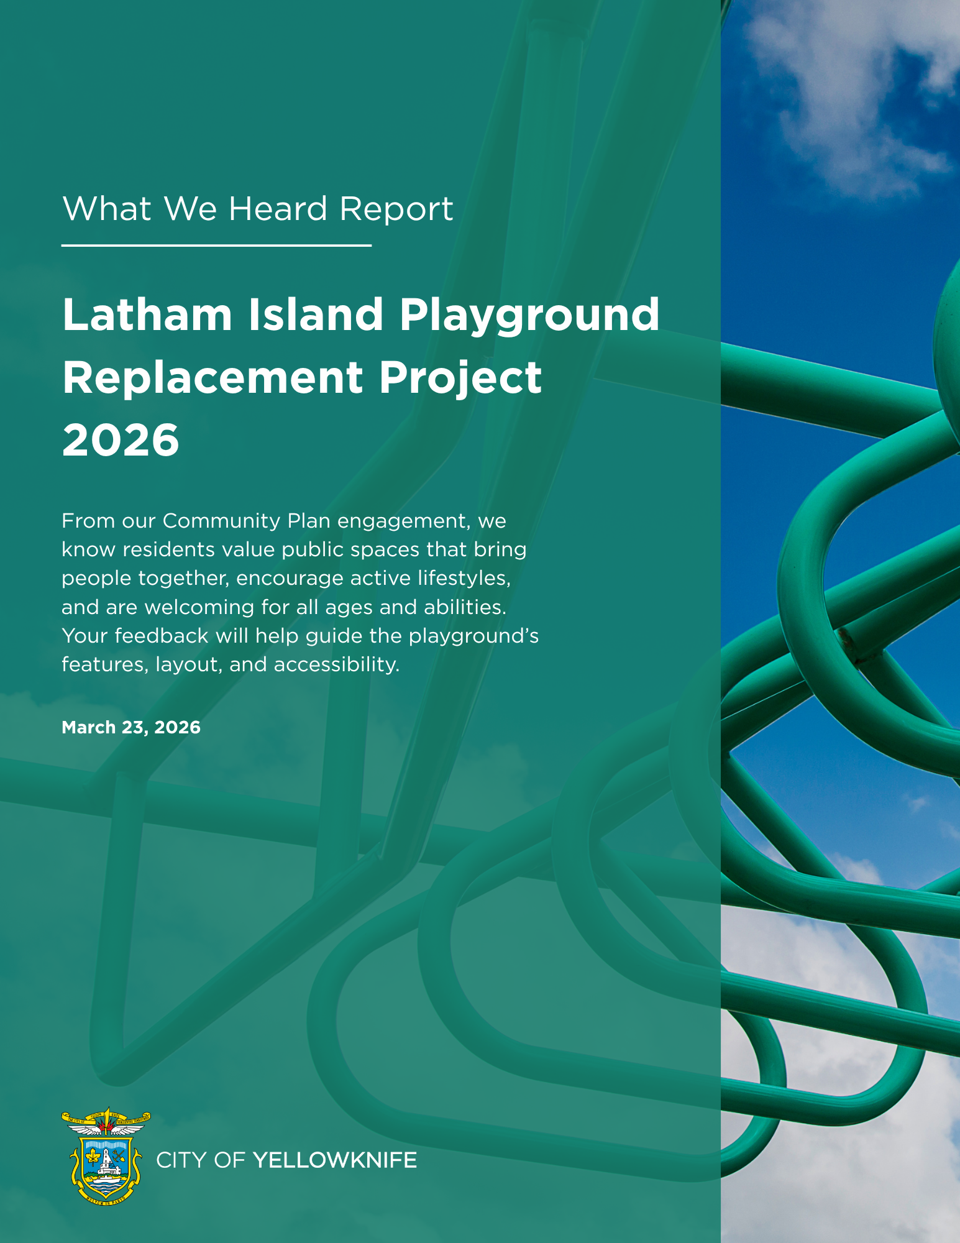

Table of Contents
1. Introduction 3
2. Engagement Approach 3
3. Demographic Profile of Participants 4
4. Key Findings 5
A) Understanding Park Usage 5
B) What Users value 6
C) Challenges & Gaps Identified 8
D) Desired Playground Improvements 10
5. Community Insights on Playground Design 12
6. What Happens Next 13

1. Introduction
Yellowknife’s parks and public spaces support recreation, connection, and community well-being year-round. The City of Yellowknife’s Community Plan Update confirmed the importance of safe, inclusive, accessible, and connected spaces to the natural environment.
As part of the Yellowknife Play Spaces 2026 initiative, the City is planning the replacement of the Latham Island Playground. The project will update the existing playground with new features to better support a range of ages and abilities.
To inform this work, the City invited residents to share input through a public survey. The survey focused on how the playground is currently used, what features are most valued, and what improvements should be considered.
This engagement was conducted at the “Consult” level of the International Association for Public Participation Spectrum of Public Participation. Feedback will inform design options alongside technical requirements, site conditions, and budget.

2. Engagement Approach
The City conducted a public survey from March 2 to March 13, 2026, to gather input on the Latham Island Playground.
This engagement was carried out at the “Consult” level of the International Association for Public Participation Spectrum of Public Participation. At this level, feedback informs planning and design decisions.
An online survey was selected as the primary engagement method to provide a quick and accessible way for residents to share input within a limited timeframe. This approach allowed the City to gather community feedback before issuing a Request for Proposals (RFP) for the playground design.
The survey was promoted through City communication channels, and 93 responses were received.

3. Demographic Profile of Participants
The survey captured input from a diverse cross-section of Yellowknife residents, with strong representation from families and frequent park users.
- 47% visit at least once per week (including 34% several times per week)
- Most respondents visit with children (41%) or with friends who have children (32%)
- 61% access the park by walking; 20% drive
- 24% households identified as adult or senior users only
The Core User Groups are identified:
- The largest user group consists of households with children aged 5–12.
- A notable overlap exists between households with children aged 0–4 and 5–12 (20 households), indicating a need for designs that accommodate multiple age groups simultaneously (“split-interest” families).
- It is recognized that individuals under 18 may also access the playground independently, highlighting the importance of safety and visibility.
A strong majority (64%) expressed a positive attitude toward visiting the playground at least once per week.

4. Key Findings
Latham Island Playground is a well-used and valued neighbourhood space that supports regular use, family activities, and community connection.
Respondents identified several key themes regarding how the park is used, which features are most valued, and which improvements should be considered.

A) Understanding Park Usage
The playground is widely regarded as accessible and convenient, with 21 respondents specifically highlighting its proximity to home. It functions as a social hub, with 73% of respondents using it for playdates, gatherings, and informal community interaction.

(Section 4A) Figure 1: Frequency of hosting playdates, gatherings, or social activities at the playground among respondents

The open green space is highly valued, particularly as a fenced area suitable for running, sports, and picnics. The park supports year-round use, though winter operations are more limited. Notably:
- Winter hill sledding was highlighted in 21% of responses as a key seasonal feature.
- Sand play remains popular (16 mentions), supporting creative and tactile activities.
- Traditional play equipment, such as swings and slides, continues to be essential.

Rank | Most-liked features of the park | Mentions
1 | Location/proximity | 21
2 | Green space / open space/grass | 18
3 | Hill/sledding / sloped ground | 17
4 | Sand/sand play | 16
5 | Slides/play structures | 11

(Section 4A) Table 1: Top 5 most-liked features of the Latham Island Park

B) What Users value
Core playground equipment, including swings, slides, and climbing structures, remains important to users.
Respondents also identified a strong need for supporting amenities, including:
- Picnic tables and benches
- Shaded or sheltered seating areas
- Seating located close to play areas for supervision

Natural elements are also highly valued. Respondents highlighted the importance of:
- Trees for shade
- Preserving existing vegetation
- Landscaping that supports safe and comfortable use

(Section 4B) Figure 1: Types of play or recreational equipment respondents would like to see

Community-oriented amenities are also highly important:
- Picnic tables (46%) and benches (43%) are frequently requested.
- Demand for overhead shelter indicates a desire for year-round usability and weather protection.

(Section 4B) Figure 2: Types of seating or gathering areas liked by respondents
Natural elements are strongly preferred:
- Trees for shading (51%)
- Landscaping that supports safe recreational activities (38%)


Shaded seating near play areas is particularly important for caregiver supervision.

(Section 4B) Figure 3: Types of environmental elements that matter to respondents

C) Challenges & Gaps Identified
Several recurring concerns were identified related to safety, infrastructure condition, accessibility, and supporting amenities.
Safety was the most frequently raised concern. Respondents identified issues related to metal slides, platform height, and weather conditions.
The main green area is too sloped to be used properly for activities like soccer… Some of the green areas are a bit swampy and buggy also - perhaps a drainage issue?

The condition of existing equipment was raised frequently, with respondents noting aging or deteriorating play structures. Concerns related to surface conditions and terrain were also frequently cited. Respondents identified uneven ground, sloped areas, and inadequate or unsafe surfacing materials as ongoing challenges, with 21 mentions highlighting these issues.
The condition of existing infrastructure was another key theme, with 24 mentions referring to deteriorating or aging equipment that requires replacement or significant maintenance. In addition, lighting and overall visibility were identified in 12 mentions as important safety considerations, particularly for extending usability and improving supervision.
Please ensure any lighting does not extend outward… for dark skies/tourism and resident enjoyment.

Accessibility limitations were also highlighted as a significant gap. Respondents noted the lack of wheelchair-accessible features, emphasizing the need for more inclusive design elements that accommodate users of all abilities. Concerns were also raised regarding insufficient accessible parking and the absence of well-defined, accessible pathways throughout the site.
Finally, gaps in supporting amenities were identified. These include the lack of public washroom facilities and limited pathways suitable for all-weather use, which can affect accessibility during rainy periods or seasonal transitions. Respondents also pointed out that the placement of benches and picnic tables near sledding areas may pose safety risks, indicating a need for more careful spatial planning in future designs.

Rank | Top 5 Issues/Concerns with the current playground | Mentions | Examples from Responses
1 | Safety | 28 | “Metal slide is dangerous”, “Kids nearly hurt themselves”, “(Kids) drop off from playground”
2 | Equipment Condition | 24 | “Equipment is old or broken”, “Dated equipment”, “Needs upgrading”
3 | Uneven / Sloped Ground | 21 | “Soccer field is slanted”, “Ground is unlevel”, “The ground has a significant slope”
4 | Accessibility / Inclusiveness | 15 | “Not accessible for wheelchairs”, “Tables installed at angle, “Nothing for toddlers”
5 | Parking / Access Issues | 13 | “No parking”, “Limited disabled parking”, “Awkward access”
(Section 4C) Table 1: Top 5 issues/concerns with the current playground

D) Desired Playground Improvements
Respondents identified several key priorities aimed at enhancing the playground’s functionality, safety, and inclusiveness. The feedback is categorized and highlighted in this section.
Rank | Top 5 Safety Concerns that should be addressed in the new playground | Mentions
1 | Lighting & visibility | 12
2 | Uneven or sloped surfaces/leveling | 11
3 | Playground surfacing (rubber, soft fall, sand issues) | 9
4 | Equipment height / age-appropriate structures | 7
5 | Sliding hill/sledding safety | 7
(Section 4D) Table 1: Top 5 safety concerns that should be addressed in the new playground

Infrastructure & Comfort
- Enhanced Lighting: A primary concern was the need for increased lighting to improve visibility and safety, particularly during lower-light conditions.
- Climate Protection: Strong demand for additional shade via natural tree canopies or built structures to ensure comfort and allow for extended use during different weather conditions.
- Social Connectivity: Respondents emphasized expanding seating and gathering areas near play zones to reinforce the park’s role as a vital community hub.
Play Features & Equipment
- Upgraded Equipment: Broad support for modernizing existing structures and introducing a greater variety of play features.
- Multi-Generational Appeal: A focus on diversifying equipment to better serve a wider range of ages and interests.
Surfacing Strategy
- Material Balance: There is a clear preference for a multi-surface approach to satisfy both accessibility requirements and diverse play needs. Respondents suggested a combination of sand and rubber could be used for the sectioned areas.
Accessibility & Inclusion
- Improved Circulation (35 mentions): A significant priority was the installation of better ramps and pathways to ensure seamless movement throughout the site.
- Sensory Integration (14 mentions): Strong interest in sensory play elements to support neurodiverse users and promote a more inclusive environment.

Rank | Top 6 Features to make the playground more inclusive | Mentions
1 | Ramps (including sloped access) | 19
2 | Paths/walkways (incl. wheelchair & stroller paths) | 16
3 | Sensory equipment | 14
4 | Accessible surface (rubber, no sand, firm ground) | 4
5 | Toddler / small children accessibility | 4
6 | Level surfaces (tables, ground, picnic areas) | 4
(Section 4D) Table 2: Top 6 Features to make the playground more inclusive

5. Community Insights on Playground Design
In addition to functional improvements, respondents also shared input on the overall look, feel, and character of the playground.
Nature-Oriented:
Many respondents expressed interest in a nature-based playground design. Common themes included:
- Forest or land-based elements
- Natural materials
- Climbing and adventure-style features
Some respondents also noted the importance of maintaining the natural character of the space.

(Section 5) Figure 1: Themes or looks liked by the respondents

Cultural & Artistic Identity:
Respondents identified opportunities to reflect local identity and community character in the playground design.
Commonly mentioned elements include:
- Local art, such as murals, sculptures, or northern-themed features
- Indigenous representation and visibility
- Storytelling or interpretive features
- References to local history or community landmarks

Rank | Top 5 cultural or community elements to be reflected in the playground | Mentions
1 | Local art (murals, sculptures, public art, northern themes) | 28
2 | Indigenous visibility/input/representation (YKDFN / Indigenous art or culture) | 25
3 | Storytelling / historical interpretation/signage | 10
4 | Community landmarks / historical features/trading post references | 6
5 | Northern or regional cultural themes | 4
(Section 5) Table 1: Top 5 cultural or community elements to be reflected in the playground

6. What Happens Next
The feedback collected through this survey will inform the public of the development of design options for the Latham Island Playground.
The City will be issuing a Request for Proposals (RFP) to engage a consultant to lead the playground design. The results of this engagement will be shared with the selected consultant to help guide the design process.
As part of the “Consult” level of the International Association for Public Participation Spectrum of Public Participation, community input will be considered alongside technical requirements, site conditions, and budget.
Updates on the project will be shared on the City’s website.

